**Question 5**

Create cursor for Employee table & extract the values from the table. Declare the variables,Open the cursor & extract the values from the cursor. Close the cursor.

Employee (E_id, E_name, Age, Salary)

**Solution:**

**1. Creating the Employee Table and insert few records**

CREATE TABLE Employee (

E_id INT PRIMARY KEY AUTO_INCREMENT,

E_name VARCHAR(255),

Age INT,

Salary DECIMAL(10, 2)

);

INSERT INTO Employee (E_id, E_name, Age, Salary)

VALUES

(1, 'Samarth', 30, 50000.00),

(2, 'Ramesh Kumar', 25, 45000.00),

(3, 'Seema Banu', 35, 62000.00),

(4, 'Dennis Anil', 28, 52000.00),

(5, 'Rehman Khan', 32, 58000.00);

**2. Create a Stored Procedure with Cursor**

DELIMITER //

CREATE PROCEDURE fetch_employee_data()

BEGIN

**-- Declare variables to store cursor values**

DECLARE emp_id INT;

DECLARE emp_name VARCHAR(255);

DECLARE emp_age INT;

DECLARE emp_salary DECIMAL(10, 2);

**-- Declare a cursor for the Employee table**

DECLARE emp_cursor CURSOR FOR

SELECT E_id, E_name, Age, Salary

FROM Employee;

**-- Declare a continue handler for the cursor**

DECLARE CONTINUE HANDLER FOR NOT FOUND

SET @finished = 1;

**-- Open the cursor**

OPEN emp_cursor;

**-- Initialize a variable to control cursor loop**

SET @finished = 0;

**-- Loop through the cursor results**

cursor_loop: LOOP

**-- Fetch the next row from the cursor into variables**

FETCH emp_cursor INTO emp_id, emp_name, emp_age, emp_salary;

**-- Check if no more rows to fetch**

IF @finished = 1 THEN

LEAVE cursor_loop;

END IF;

**-- Output or process each row (for demonstration, print the values)**

SELECT CONCAT('Employee ID: ', emp_id, ', Name: ', emp_name, ', Age: ', emp_age, ', Salary: ', emp_salary) AS Employee_Info;

END LOOP;

**-- Close the cursor**

CLOSE emp_cursor;

END;//

DELIMITER ;

To check strored procedure, select the database (not the table) and then click on Routines*******

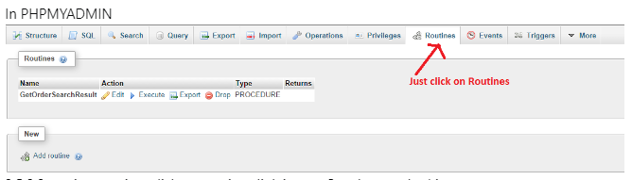

**3. Execute the Stored Procedure**

CALL 'fetch_employee_data'();